1. Exit Interview Master

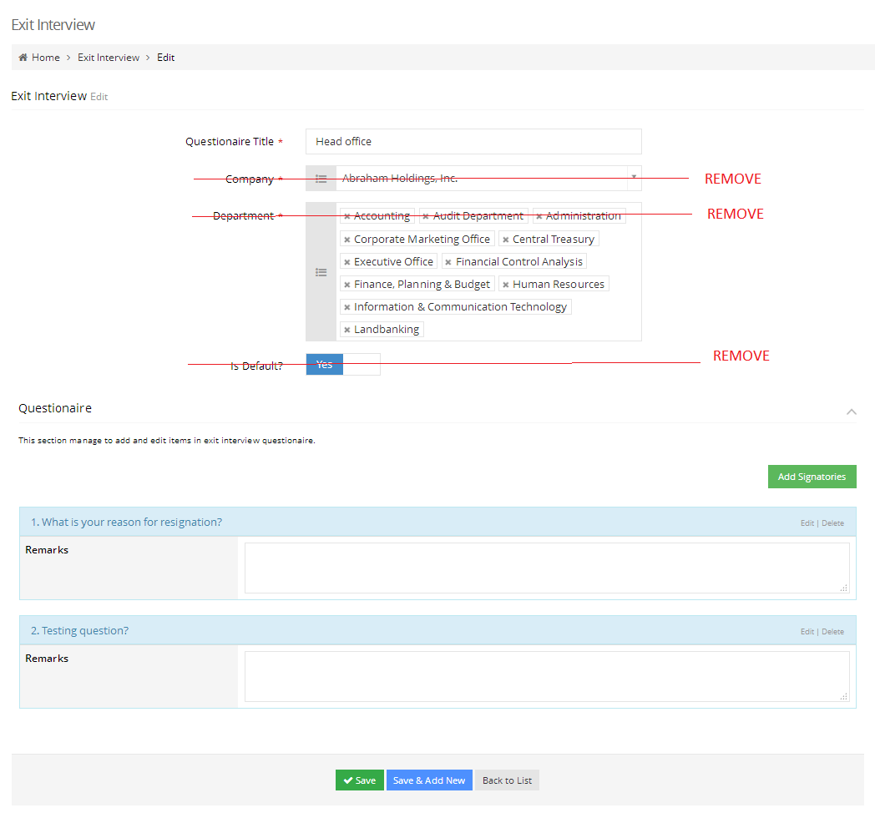

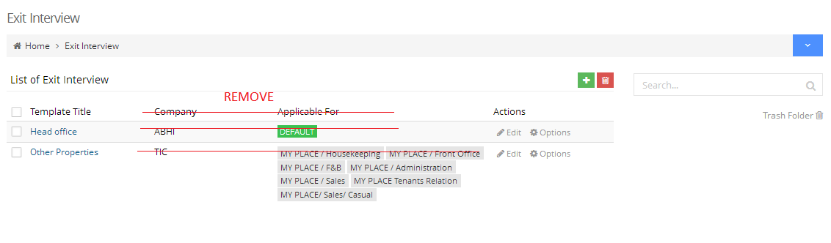

1. Clearance Signatories

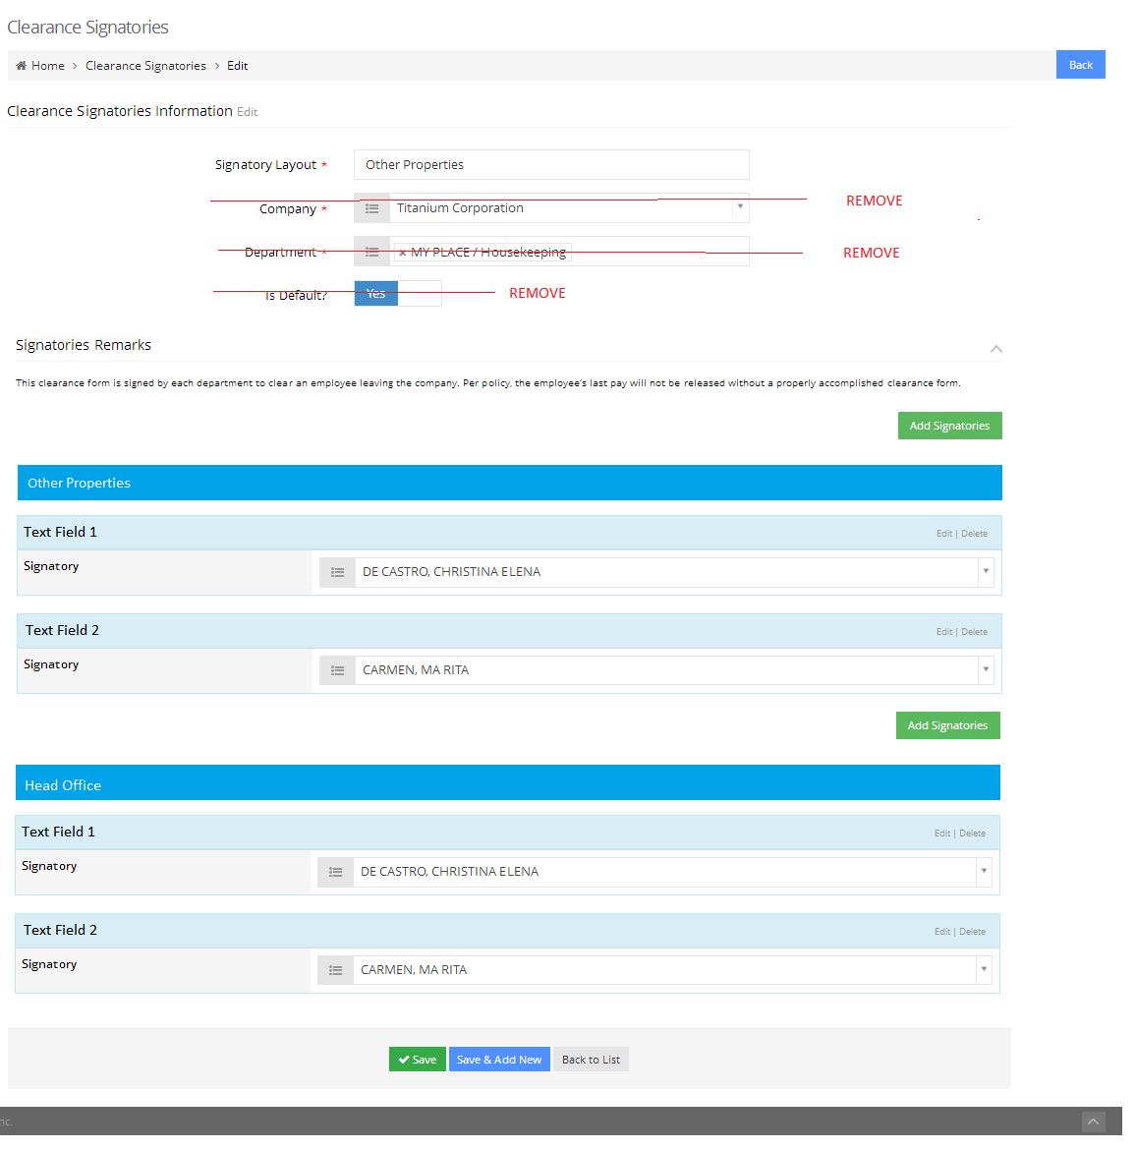

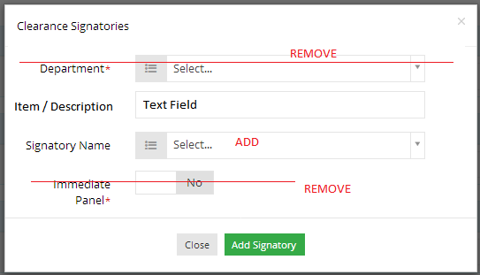

Note: Added Signatory Name will be the default signatory per item / description.

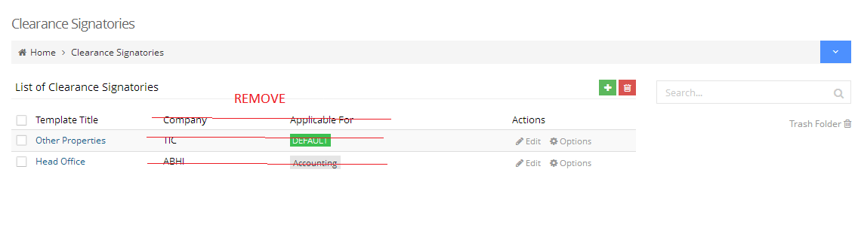

1. Clearance

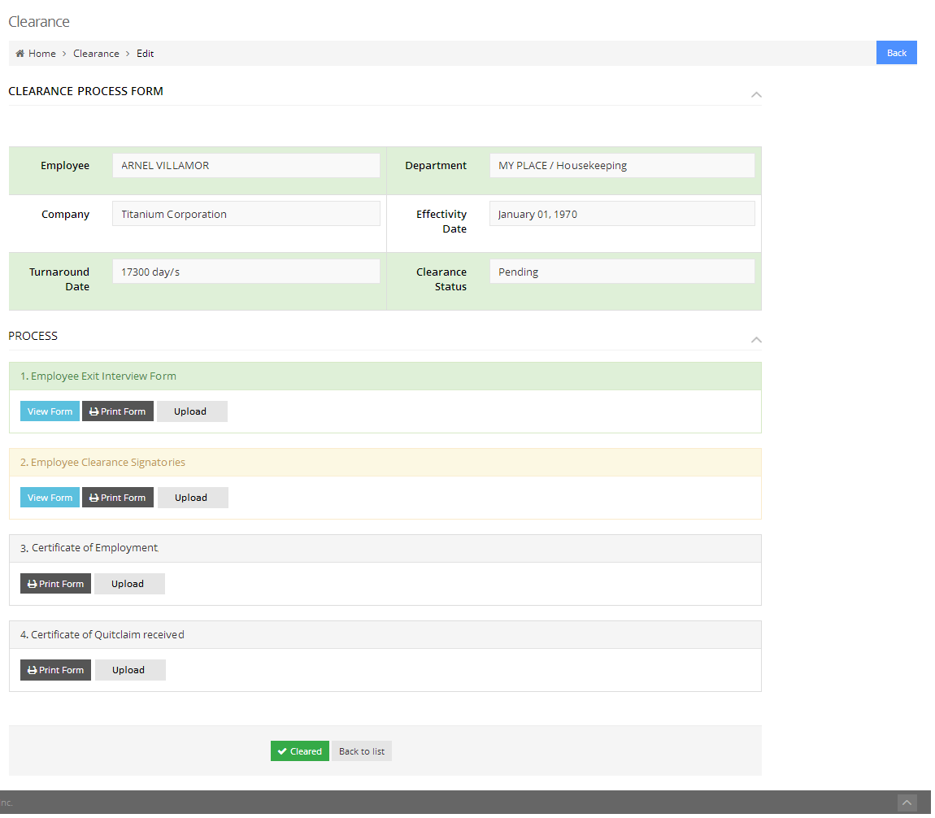

Employee Clearance Signatories

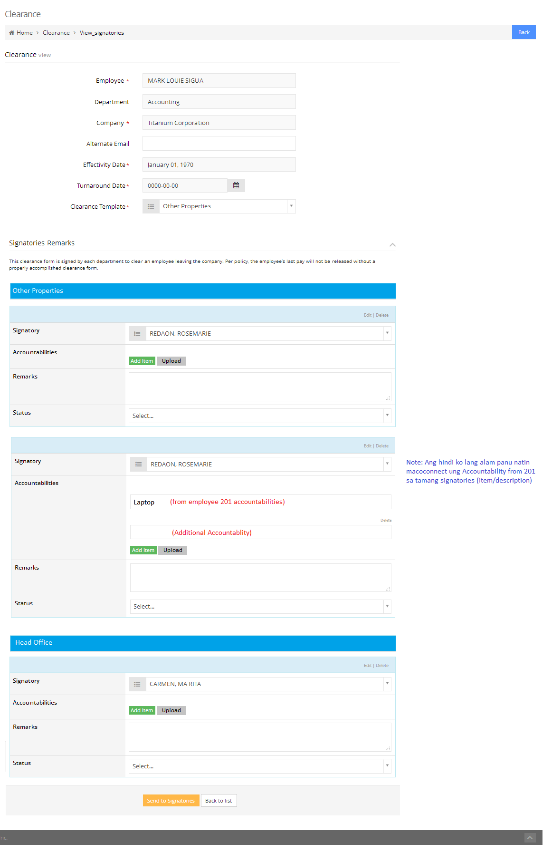

Note: Apply same UI to all signatories.